Project Design Phase-II
Technology Stack (Architecture & Stack)

Date | 03 Oct 2026
Team ID | Team 12
Project Name | Streamlining IT Procurement: Automating Standard Laptop Orders with Flow Designer
Maximum Marks | 4 Marks

Technical Architecture:
The Deliverable shall include the architectural diagram as below and the information as per the table1 & table 2
Example: Order processing during pandemics for offline mode
Reference: https://developer.ibm.com/patterns/ai-powered-backend-system-for-order-processing-during-pandemics/
Guidelines:
Include all the processes (As an application logic / Technology Block)
Provide infrastructural demarcation (Local / Cloud)
Indicate external interfaces (third party API’s etc.)
Indicate Data Storage components / services
Indicate interface to machine learning models (if applicable)
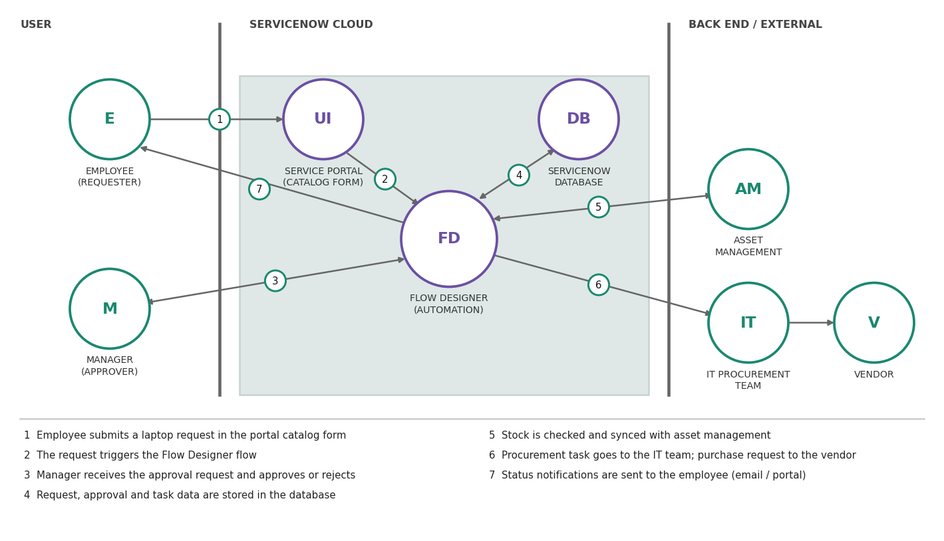

Table-1 : Components & Technologies:
S.No | Component | Description | Technology
 | User Interface | Employee submits and tracks the request; manager approves or rejects it. | ServiceNow Service Portal (HTML, CSS, JavaScript, AngularJS)
 | Application Logic-1 | Request submission: catalog item, auto-fill of user details, field validation. | ServiceNow Service Catalog, Catalog Client Scripts (JavaScript)
 | Application Logic-2 | Approval: routes to manager, sends reminders, escalates after 48 hours. | ServiceNow Flow Designer (flow and approval actions)
 | Application Logic-3 | Fulfilment: creates procurement task and purchase request, sends notifications. | Flow Designer actions and subflows, Notifications
 | Database | Stores requests, approvals, tasks and user records. | ServiceNow relational database (sc_request, sc_task, sys_user)
 | Cloud Database | Database service hosted on the cloud with the instance. | ServiceNow cloud-hosted instance database
 | File Storage | Attachments such as quotations and delivery proof. | ServiceNow attachment storage (sys_attachment)
 | External API-1 | Sends purchase requests to the vendor for out-of-stock laptops. | Vendor REST API via IntegrationHub
 | External API-2 | Sends confirmation and status emails. | Email service (SMTP)
 | Machine Learning Model | Not used, as the solution is rule-based automation. | Not applicable
 | Infrastructure (Server / Cloud) | Deployed on the cloud, not on a local system.  Local Server Configuration: Not required  Cloud Server Configuration: ServiceNow instance | Cloud (ServiceNow instance)

Table-2: Application Characteristics:
S.No | Characteristics | Description | Technology
 | Open-Source Frameworks | Open-source frameworks and libraries used for the portal user interface. | AngularJS, Bootstrap (Service Portal)
 | Security Implementations | Role-based access control and ACLs, single sign-on login, encrypted communication and audit logs of approvals and changes. | ServiceNow roles and ACLs, SSO (SAML), HTTPS / TLS, OWASP guidelines
 | Scalable Architecture | Multi-tier architecture (UI, application and database tiers); new catalog items and approval rules are added through configuration. | ServiceNow 3-tier architecture, Flow Designer subflows
 | Availability | Application runs on the cloud platform with redundant data centers and failover; maintenance is planned outside business hours. | ServiceNow cloud with primary and secondary data centers
 | Performance | Flows run asynchronously, queries use indexed fields, and dashboards give quick status views without manual reports. | Flow Designer asynchronous execution, indexed tables, reports and dashboards

References:
https://c4model.com/
https://developer.ibm.com/patterns/online-order-processing-system-during-pandemic/
https://www.ibm.com/cloud/architecture
https://aws.amazon.com/architecture
https://medium.com/the-internal-startup/how-to-draw-useful-technical-architecture-diagrams-2d20c9fda90d

